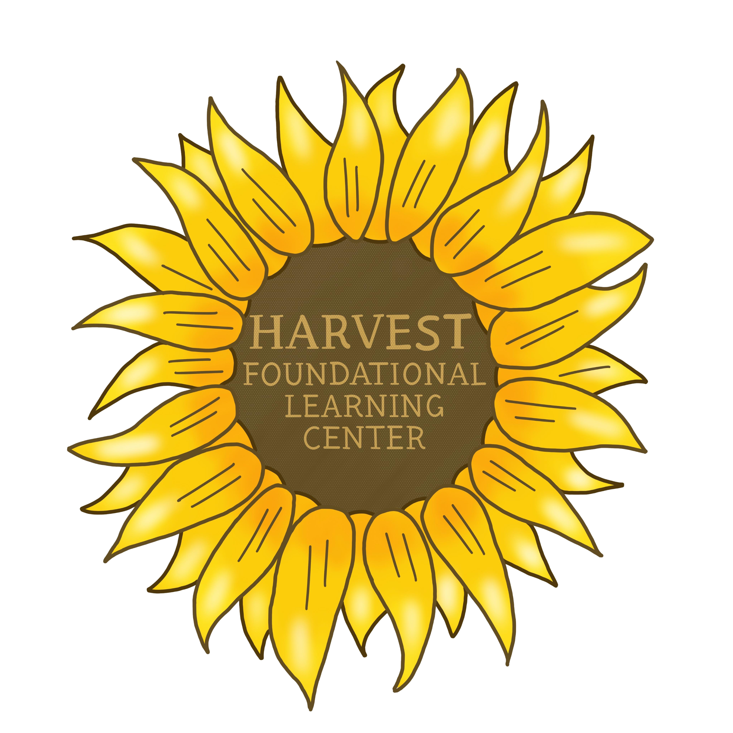
Harvest Foundational Learning Center Application
Fall 2020

Student Information

Student First Name Student Last Name

______________________________ _______________________________

Gender
Male___ Female___ Non-binary___ Prefer not to answer___

Student Date of Birth Home Language(s)

___/____/______ __________________

Ethnicity
Select all that apply
- Asian
- Asian Indian
- Black or African American
- Native American and Alaskan Natives
- Native Hawaiian and Other Pacific Islanders
- White/Caucasian
- Other

Current School Current Age

_____________________ ___________

Household Information

Street address

_______________________________________________________

City State Postal Code

_______________________ __________________ ______________

Country/Region

_____________________________
Parent Information

Parent/ Guardian 1

First name Last name

__________________________ _____________________________

Email Phone number

__________________________ __________________________

Relationship to Applicant

________________________________

Questions

Does the applicant have siblings?
- Yes
- No

Please tell us about your expectations for your child’s education and what you are looking for in Harvest Foundational Learning Center.

Please tell us about your child’s social and academic level and needs.

Please share with us your child's daily routine, personality and areas of interest.

Is your child currently under the care of a physician, psychiatrist, psychologist or therapist?
- Yes
- No

Does your child have any allergies or learning differences?
- Yes
- No

Is there anything else you would like us to know about your child?

Student Photo and Birth Certificate
*attach copy

Parent Signature Date

_____________________________________ _________________

